Create Table STUDENT3 (

S_ID INT PRIMARY KEY,

Sname Varchar(50),

Physics INT,

Chemistry INT,

Mathematics INT,

Totalmarks INT

);

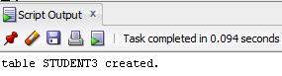

DESC STUDENT3;

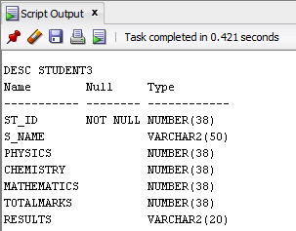

Insert Into STUDENT3 Values (1, 'Max', 20, 18, 45);

Insert Into STUDENT3 Values (2, 'Jane', 12, 10, 20);

Insert Into STUDENT3 Values (3, 'Mike', 25, 25, 50);

Insert Into STUDENT3 Values (4, 'Steve', 15, 16, 24);

Insert Into STUDENT3 Values (5, 'Bob', 5, 8, 15);

Insert Into STUDENT3 Values (6, 'Alice', 18, 20, 48);

Insert Into STUDENT3 Values (7, 'Lucas', 14, 14, 35);

Insert Into STUDENT3 Values (8, 'Dustin', 11, 12, 25);

Insert Into STUDENT3 Values (9, 'Suzie', 23, 21, 49);

Insert Into STUDENT3 Values (10, 'Jaden', 16, 15, 38);

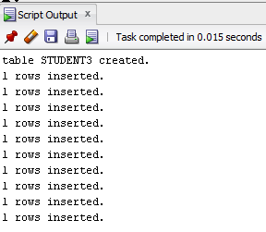

Select * From STUDENT3;

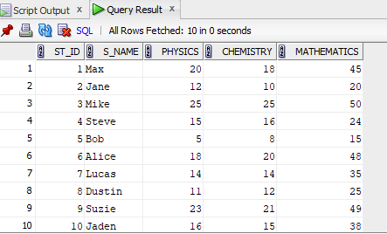

**QUESTIONS**

1.SELECT AVG(Physics) AS avg_physics FROM STUDENT3;

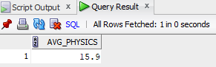

2.Select MAX(Mathematics) As Highest_Marks_Mathematics FROM STUDENT3;

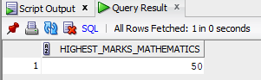

3.SELECT MIN(Chemistry) AS lowest_mark_chemistry FROM STUDENT3;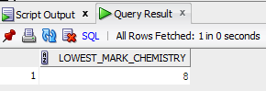

4.SELECT COUNT(*) AS physics_passed FROM STUDENT3 WHERE Physics>= 12;

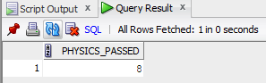

5.SELECT * FROM STUDENT3 WHERE Physics >= 12 AND Chemistry >= 12 AND Mathematics >= 25;

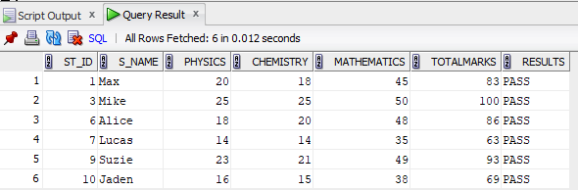

6. Select S_Name, Physics, Chemistry, Mathematics, (Physics + Chemistry + Mathematics) AS total, Case WHEN Physics >= 12 AND Chemistry >= 12 AND Mathematics >= 25 THEN 'Pass' Else 'Fail' End As Result, Rank()Over(Order By(Physics + Chemistry + Mathematics) Desc ) As Rank From Student3 Order By Rank;

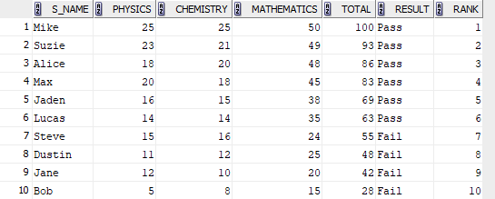

7.SELECT (COUNT(MATHEMATICS))/10*100 AS MATHS_PASS_PERCENTAGE FROM STUDENT3 WHERE MATHEMATICS>24;

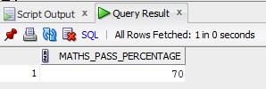

8.SELECT (COUNT(S_name))/10*100 AS ALL_PASS FROM STUDENT3 WHERE Physics>11 AND Chemistry > 11 AND Mathematics >24;

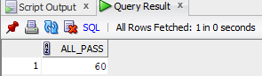

9.SELECT AVG(TOTALMARKS) AS TOTALMARKS_AVG FROM STUDENT3;

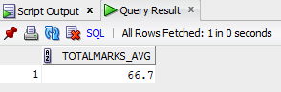

10. SELECT COUNT(*) AS total_pass_students FROM STUDENT3 Where Physics>= 12 And Chemistry>= 12 And Mathematics >= 25;

